PowerShellScript from fetching SQL product key

- Uses function Get-SqlServerKeys for fetching SQL product key supports from 2005 to 2019

- Prerequisite running script it requires PowerShell Version 3.0, SQL Server SMO, Remote Registry
- Get-sqlserverkey multiple parameter we can fetch details in different ways for example:
a. Get-SqlServerKeys winxp, sqlservera, sqlserver2014a, win2k8
Its Gets SQL Server versions, editions and product keys for all instances within each server
b. Get-SqlServerKeys -CentralMgmtServer sqlserver01
Its Gets SQL Server versions, editions and product keys for all instances within sqlserver01's Central Management Server
C. Get-SqlServerKeys -ServersFromFile C:\Scripts\servers.txt
Gets SQL Server versions, editions and product keys for all instances listed within C:\Scripts\servers.txt

- Tested script on sqlandalwayson1 server

1.Checking powershell Version: Get-Host | Select-Object Version

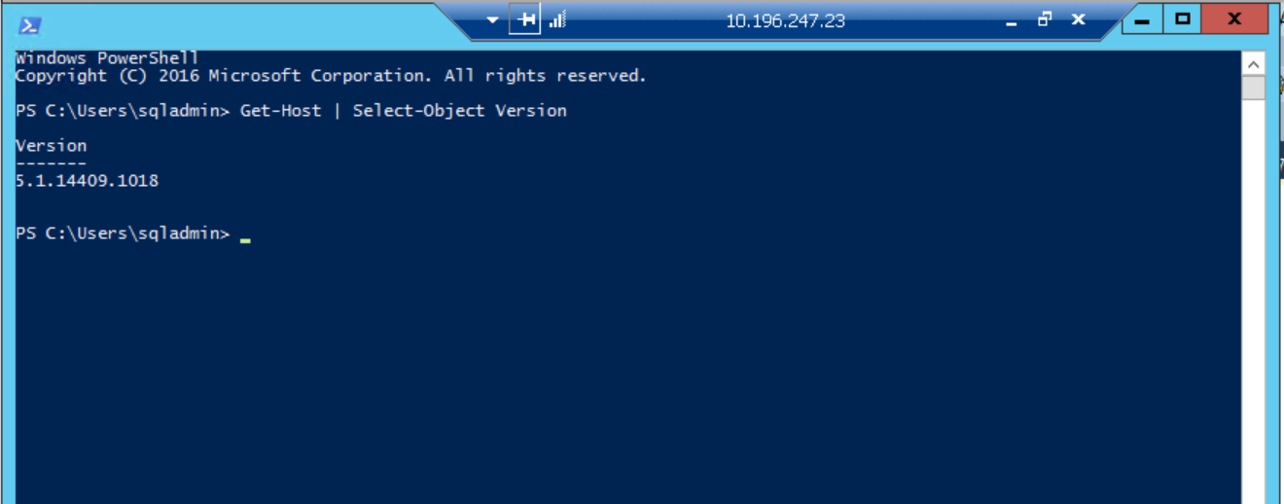

2. create function Get-SqlServerKeys
in powershell:
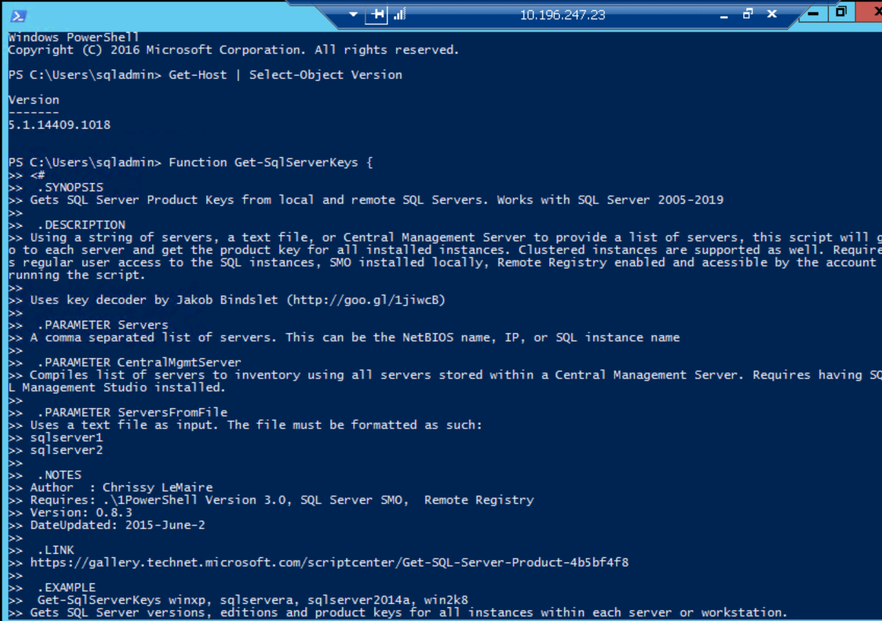

3. Execute fuction in powershell:

a.Default it will provide product key details of local servers as we have not passed parameters
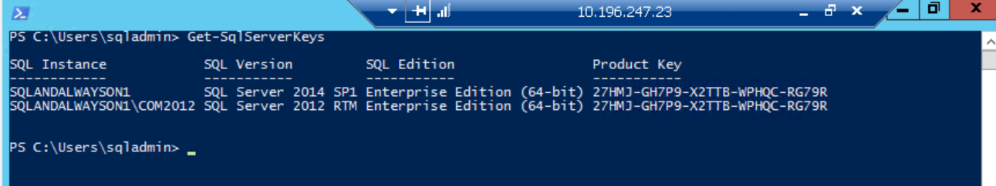

b. passing server name as parameter:
Get-SqlServerKeys SQLANDALWAYSON1
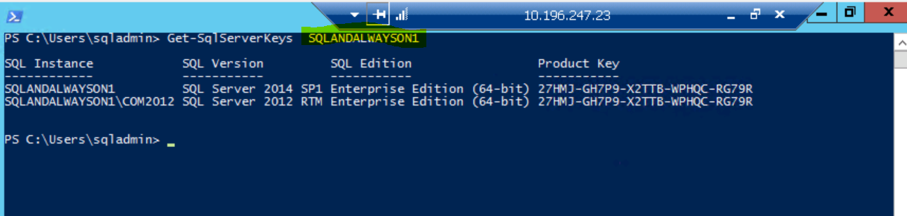
3. providing servernames in text file
Get-SqlServerKeys -ServersFromFile C:\servers.txt
